CALL FOR PROPOSALS

USER-ASSISTED COMMISSIONING of EXPERIMENTAL STATIONS in the E1 EXPERIMENTAL HALL of ELI BEAMLINES

February 15, 2019 - August 30, 2019

The ELI Beamlines Facility (https://www.eli-beams.eu/en/) invites the scientific community to submit proposals for commissioning experiments in its E1 Experimental Hall that serves experiments for Applications in Molecular, Biomedical and Materials Sciences. The commissioning experiments of new experimental stations will take place between February 15 and August 30, 2019.

We invite specially qualified users to assist with instrument commissioning and to perform early experiments.

The aim of the call is
- to perform high-level instrument commissioning and to initiate high-level user experiments, using the capabilities already in operation in the E1 experimental hall.
- to increase the future value of the experimental capabilities of E1 for the broader user community by ensuring that the final development and commissioning steps are completed in collaboration with leading international experts.
- to train ELI Beamlines scientific staff, user office personnel and support teams together with experienced users in the interactions necessary for efficient user operations.

List of instruments available for user-assisted commissioning, including methods developments and early experiments
- MAC: Multi purpose end station for AMO science and Coherent Diffractive imaging WEBSITE with the information in the document „MAC_v1“
- ELIps: Time resolved spectroscopic ellipsometry and VUV material science WEBSITE with the information in the document „ELIps_v1“
- TREX: Station for X-ray experiments, in particular diffraction, scattering, spectroscopy imaging and pulse radiolysis WEBSITE with the information in the document „TREX_v1“
- Femtosecond spectroscopy: Femtosecond Stimulated Raman Scattering, transient optical absorption, IR spectroscopy and pulse shaping WEBSITE with the information in the document „Femtosecond spectroscopy_v1“

Introductory information about lasers, VUV and X-ray sources available for the call can be found here.
Link to a web page with the information in the documents “Lasers_v1” and “HHG source v1”.

Applicants must be aware and accept that the ELI Beamlines will be in a "ramp-up mode" during the time of the commissioning experiments and this may affect the performance and availability of the individual instruments.

Application submission Deadline:
Continuous. Expected time from submission to decision is 4 weeks

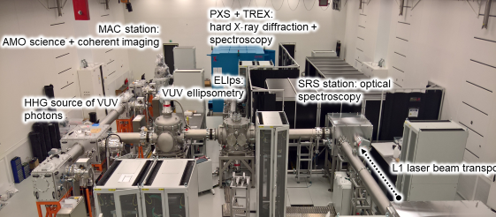
ELI Beamlines experimental hall E1.

Application procedure and admittance
On-line application forms are generated from the instrument pages where the updated information on the status and availability of individual instruments and planned commissioning activities is provided.

All applications will be processed by the user administration at ELI Beamlines user.office@eli-beams.eu. Submitted proposals will go through a feasibility assessment headed by the lead scientist of the experimental station in question and be selected or rejected based on an evaluation against the aims of the call stated above and the feasibility of the proposed experiments. Experiments will be scheduled or rejected on the basis of scientific merit in relation to the aims of the call, feasibility and safety assessment. Results will be communicated to the applicants by the user office of ELI Beamlines.

The lead scientist of the instrument in question will assign one suitable researcher of the ELI Beamlines' team to be the main point of contact for the experiment. The ELI researcher will automatically become a co-proposer of the user-assisted commissioning experiment. The main point of contact will be responsible for communications with the users before, during and after the experiment, including aspects related to bringing user equipment to ELI Beamlines. Beam time of about 2 weeks will be allocated per experiment with approximately 8 hours of user beam per day. Shorter and longer experiments will also be considered.

Before gaining access to the premises of ELI Beamlines, users must complete relevant trainings (e.g. general safety, laser safety training). This will be provided by the ELI Beamlines safety team either as on-line training or on-site training as appropriate. A list all relevant safety trainings can be found here.

Useful general information about the ELI Beamlines facility can be found in the ELI Beamlines User-guide.

User-supplied instrumentation and equipment
In Early User Operation, the use of own instrumentation or equipment in the experiments is not encouraged for feasibility and integration reasons. If you are planning to include in your proposal user-supplied instrumentation or equipment, please contact the relevant scientific instrument team well before proposal submission in order to verify feasibility. Rules for user-supplied instrumentation and equipment can be found here.

Data and publication policies
The following general guidelines apply for data generated at ELI Beamlines during the present call:
- All raw data and the associated metadata obtained as a result of public research will be made available as open access after an initial embargo period during which access is restricted to the experiment team, represented by the PI.
- Any publication which contains data or metadata generated during the user assisted commissioning experiments shall acknowledge the use of the ELI Beamlines facility and its funding sources (exact wording of the acknowledgement shall be agreed with the leading ELI scientist for the instrument where the data were generated).
- The ELI scientific staff involved with the external users in the user assisted commissioning and early user experiments shall be offered co-authorship of publications that come out of the joint experiments according to good scientific practice.
- ELI Beamlines will store the data generated in the user assisted commissioning experiments according to its best ability but assumes no formal responsibilities for data storage. Users are expected to take home a copy of the data.
- Ownership, including any IP rights that might arise, of all results derived from the analysis of the raw data is determined by the contractual obligations of the person(s) performing the analysis respectively the applicable law.
- References for publications related to experiments carried out at the ELI Beamlines Facility must be deposited in the ELI Beamlines publications database within three months of the publication date, or during any new application for beam time, whichever is earlier.

MAC: Experimental station for AMO science and Coherent Diffractive Imaging

For the user programme in AMO science and Coherent Diffractive Imaging we are presently seeking users to work with during final instrument commissioning and further methods development of the following systems:

- Commissioning of the refocusing optic to the MAC experimental station. First experiments with electron and ion spectroscopy. Excitation and fragmentation of gas phase atoms, molecules, clusters and bio/nano-particles

Time frame: April 2019.
Contact person: Maria Krikunova, email: Maria.Krikunova@eli-beams.eu
Application form

- Commissioning of the Velocity Map Imaging spectrometer

Time frame: July 2019
Contact person: Maria Krikunova, email: Maria.Krikunova@eli-beams.eu
Application form

- Commissioning of the pump-probe set up for measurements with synchronized NIR/VUV pulses.

Time frame: August 2019.
Contact person: Maria Krikunova, email: Maria.Krikunova@eli-beams.eu
Application form

In case you are interested in working with us through the instrument commissioning in the E1 experimental hall and on the development of further functionalities of the MAC end station, or if you want to use the instrument for general AMO science applications, please fill in the user contact form following the links above.

Brief description of the available set up
The MAC end station is a Multipurpose end station for AMO (Atomic, Molecular and Optical) and CDI (Coherent Diffractive Imaging) science. The design of the MAC vacuum chamber is similar to that of the LAMP chamber in the AMO station at LCLS and the CAMP chamber now located at FLASH, DESY.

Spectrometers and detection systems
At present the following spectrometers and detection systems are operational or in the commissioning pipeline:
- Electron and ion Time of Flight spectrometers (in house development)
- Velocity Map Imaging (VMI 75 mm MCP with a phosphor screen imaged by a camera with 166 fps 1936 x 1216 pix Sony CMOS 1/1.2" sensor 72 dB (~ 12 bit resolution)) with ns gated imaging detector (Velocitas/Photec)

Sample delivery
At present the following sample delivery/handling systems are operational or in the commissioning pipeline:
- Fixed target stage
- Gas target – either needle source or a molecular beam.
- Cluster source – for rare-gas and water clusters with sizes from few nm to 100s nm.
- Aerosol injection systems – GDVN aerosol injector or Electrospray Ionization.

Time-preserving monochromator:
4 sets of gratings covering the range (1) 10 to 28 eV, (2) 25 to 54 eV, (3) 51 to 98 eV and (4) 86 to 121 eV. Manually selectable exit apertures 50, 100, 200 and 300 μm.

External collaboration with Luca Poletto, Fabio Frassetto (Institute of Photonics and Nanotechnologies, National Research Council of Italy, via Trasea 7, I-35131 Padova, Italy)

HHG focusing
Ellipsoidal mirror with 1:4.8 imaging ratio

NIR focusing
90deg off-axis parabola with focal length of 101.6 mm. Hole in the parabola mirror allows collinear focusing of HHG and IR beam.

Available NIR/HHG delay range
Is covered by a 1 m delay line

Pump-probe capacities
We invite users interested in establishing pump-probe capabilities with monochromatized HHG and optical laser beams. For an updated status of the pump-probe setup please contact the MAC instrument team for the latest updates (email to instrument scientist).

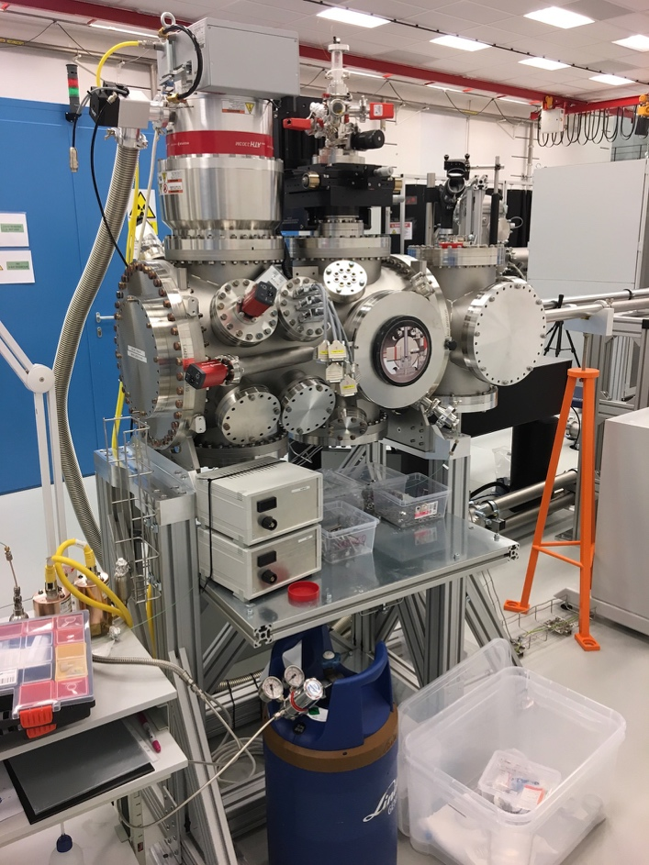
The MAC end station during installation in the E1 experimental hall.

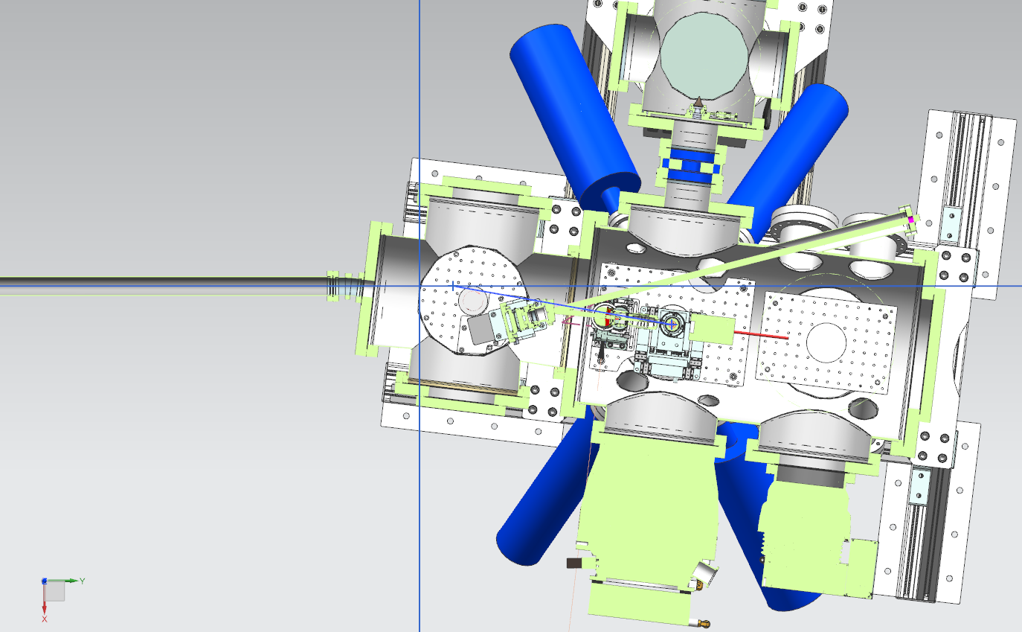
Model of the MAC station with two different focal geometries. One using a 10 degrees grazing incidence ellipsoidal mirror (current geometry) and another utilizing a 11 degrees angle of incidence Off Axis Parabola (optional geometry).

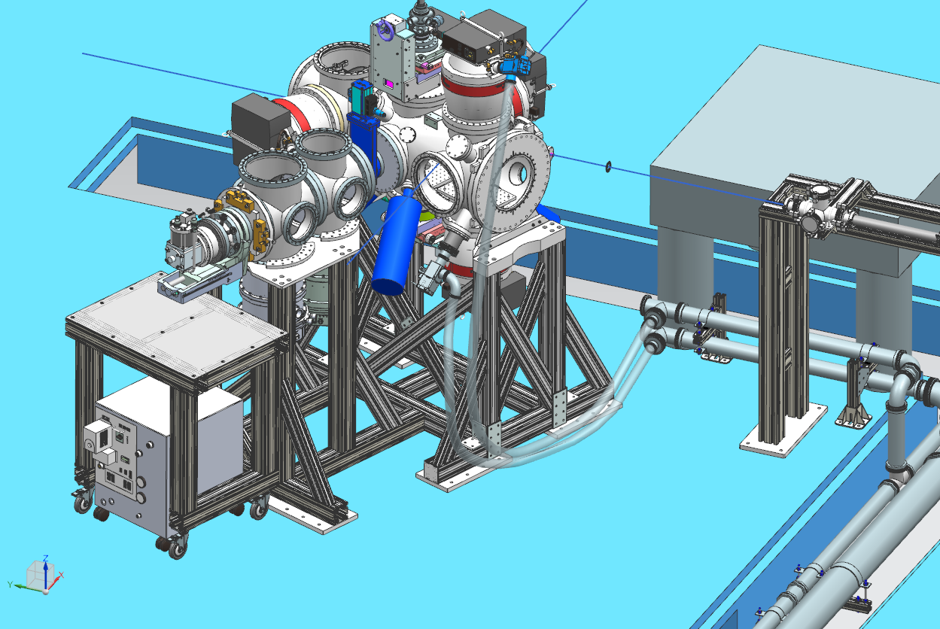
Model of the MAC station on the beamline location. In this image the station is equipped with the aerosol injector mounted from the top of the main chamber and a cluster source with a cryo-cooled Even Lavie nozzle (under development) mounted from the side.

ELIps Pump-probe spectroscopic ellipsometry and VUV material science

For the user programme for pump-probe spectroscopic ellipsometry and VUV material science the following instrument is available for user operation:

- Pump-probe spectroscopic ellipsometer for the NIR to NUV

Time of availability: Ongoing
Contact person: Shirly Espinoza, email: ShirlyJosefina.EspinozaHerrera@eli-beams.eu
Application form

We are presently seeking users whom would like to study phenomena happening in solid state materials on an ultra-fast time scale using this unique instrument and work with us to explore and develop its further functionalities. To apply for using this instrument please follow the link here.
Link to application form

Brief description of the available set up:
Pump-probe spectroscopic ellipsometry:
Our femtosecond pump-probe ellipsometer measures the polarization response of planar samples which allows the calculation of the optical constants of the material in an excited state and during the time evolution of these states. It is a P-S-C_{R}-A ellipsometer. Other characteristics of the systems are:
Wavelengths pump beam: 266 nm, 400 nm or 800 nm
Spectral range probe: 350 nm - 700 nm (1.8 eV - 3.5 eV) based supercontinuum generation in CaF₂ or similar
Spectral bandwidth: approx. 25meV (prism based spectrometer)
Probe spot size at the sample: <200um
Time range: 0-5 ns
Time resolution: 100 fs
Dynamic range: 10000:1
Characteristic of the pulses from the laser: 20 to 35 fs, 1 KHz rep.rate. (Coherent Astrella or Femtolaser Femtopower support laser)
Angle of incidence: 20-90degree
Sample requirements:
Sample size: 50 um or bigger
Roughness < 350 nm
Stable in air (upgrade: in solution)
Preferentially thin films on transparent substrates that can be homogeneously excited by the pump
The transient ellipsometry spectra are obtained from a series of background and luminescence corrected reflectance spectra.

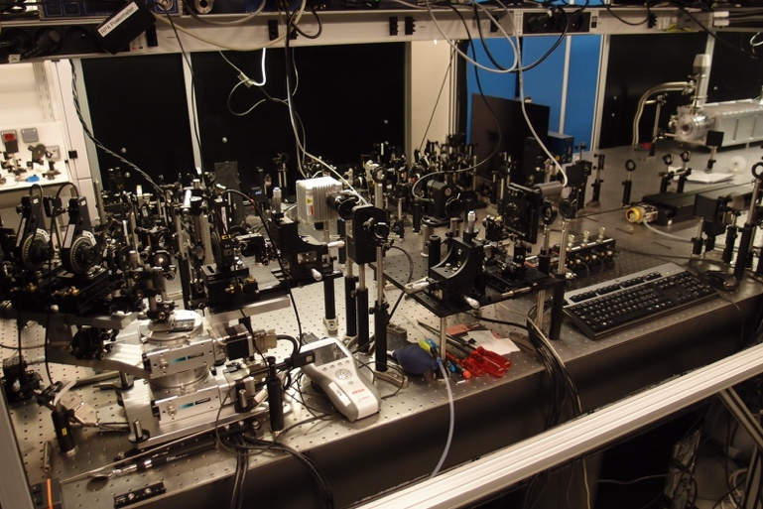
Fig: Set up for pump-probe spectroscopic ellipsometry in operation in the E1 experimental hall.

TREX: Hard X-ray science, diffraction and scattering, spectroscopy, imaging and pulse radiolysis

For the user programme in hard X-ray science we are presently seeking users to work with us on instrument commissioning and further methods development of the following systems:

- X-ray diffraction and/or scattering experiments in the field of protein crystallography using the complementary sealed tube X-ray source.

Time frame: Ongoing.
Contact person: Borislav Angelov, email: Borislav.Angelov@eli-beams.eu
Application form

- X-ray diffraction and/or scattering experiments in the field of material science, using the complementary sealed tube X-ray source.

Time frame: Quarter 2 2019.
Contact person: Borislav Angelov, email: Borislav.Angelov@eli-beams.eu
Application form

In case you are interested in working with us on the development of further functionalities on the hard X-ray instruments, please fill in the user contact form following the links above.

Brief description of the available set up:

The X-ray diffractometer is based on a custom modification of a commercial STOE STADIVARI goniometer. It has the same functionality as the commercial analog plus in addition an extended range for the detector movement going up to 400 mm sample to detector distance. The main module of the diffractometer is the so called Euler cradle goniometer, which is capable of simultaneously rotating the investigated sample at 360 degree and at the same time to position the X-ray detector at desired angle and distance from the sample. It comes with a computer controlled video microscope and dimmable led light. The cryo cooling for the fragile biological sample is implemented via a commercial cryo stream cooler from Oxford Cryosystems. The recording of the diffracted and scattered X-ray photons is accomplished by a single photon counting hybrid pixel detector model Eiger X 1M from Dectris company. Another module is the X-ray microfocus sealed tube with Montel optics and JJ X-ray pinhole collimation.

The instrument for hard X-ray science is outlined in the figure below.
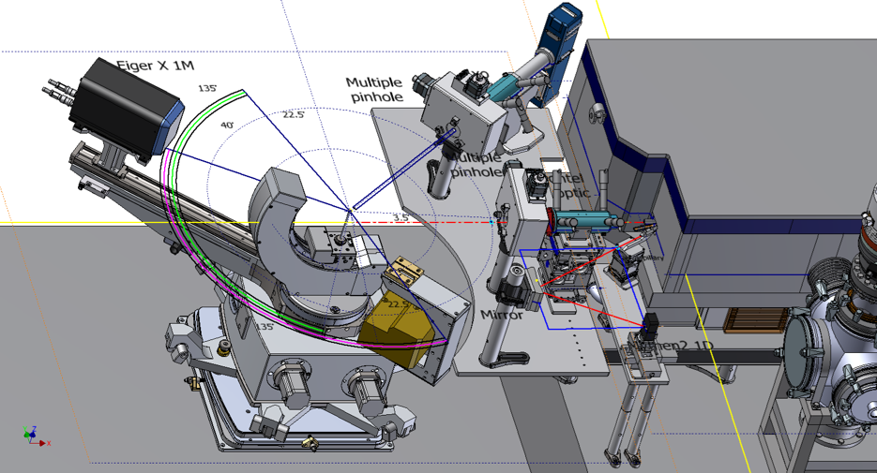
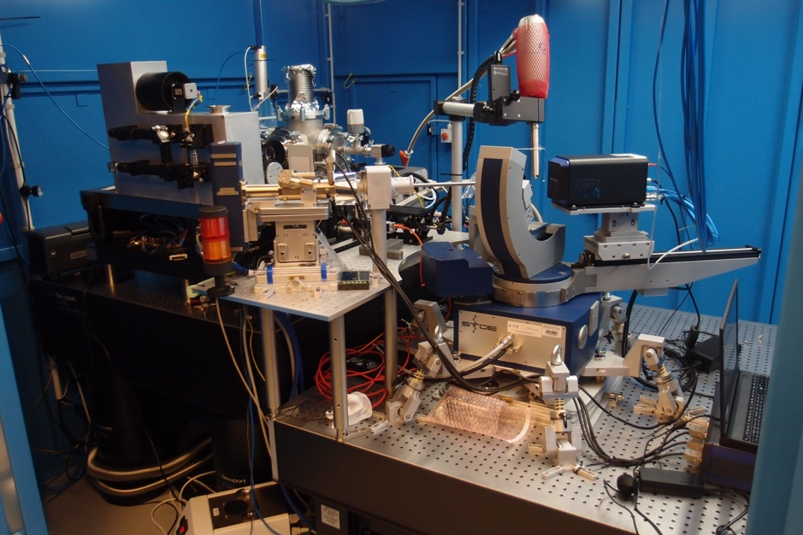
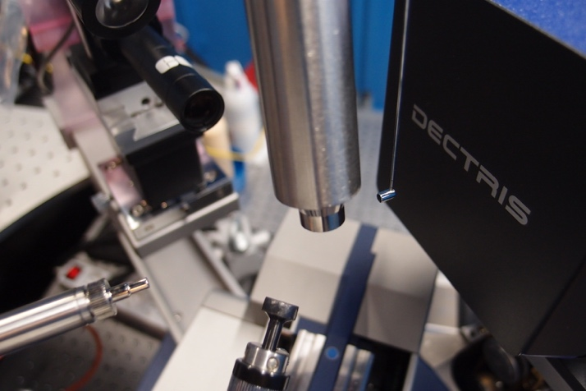
Fig. Top: Hard X-ray experimental station as designed, including the laser driven Plasma X-ray source, a complementary sealed tube Cu-anode X-ray source, diffractometer and von Hamos spectrometer for absorption spectroscopy. Middle: Diffraction station as built (presently available for users with the complementary sealed tube X-ray source). Bottom: detail of the diffractometer sample environment when optimized for protein crystallography with the cryostream cryocooler.

Technical Data
Sealed tube X-ray beam parameters
Flux on the sample | 10^8 ph/sec
Beam size | 145 micrometers
Beam divergence | 4.8 mrad
Beam polarization | 40%
Wavelength | CuKa 1.54 Angstroms
Detector parameters
Pixel size [µm2] | 75 x 75
Sensitive area (width x height) [mm2] | 77.2 x 79.9
Total number of pixels | 1030 x 1065 = 1,096,950
Maximum frame rate [Hz] | 3000
Frame dead time | 3 μs
Point-spread function | 1 pixel
Sensor thickness [μm] | 450
Threshold energy [keV] | 2.7-18
Maximum count rate [phts/s/mm2] | 5x10^8
Counter bit depth [bit] | 12
Image bit depth [bit] | 16 or 32
Photon processing time per pixel | 180 ns
Data format | HDF5
Sample to detector distance | 40-400 mm

Optical spectroscopy: Stimulated Raman Scattering, transient absorption, IR spectroscopy (1 and 2D) and pulse shaping

For the user programme in optical spectroscopy we are presently seeking users to work with on the final instrument commissioning and further methods development of the following systems:

- femtosecond Stimulated Raman Scattering.

Time frame: Ongoing.
Contact person: Miroslav Kloz, email: Miroslav.Kloz@eli-beams.eu
Application form

- Transient optical absorption spectroscopy.

Time frame: Ongoing.
Contact person: Miroslav Kloz, email: Miroslav.Kloz@eli-beams.eu
Application form

- IR spectroscopy (1 and 2D).

Time frame: March 2019
Contact person: Miroslav Kloz, email: Miroslav.Kloz@eli-beams.eu
Application form

- Pulse shaping and coherent control

Time frame: Ongoing.
Contact person: Miroslav Kloz, email: Miroslav.Kloz@eli-beams.eu
Application form

In case you are interested in working with us on the development of further functionalities of the optical spectroscopy stations, or in conducting experiments on the existing set ups, please fill in the user contact form following the link here.

Brief description of the available set ups:

- Femtosecond Stimulated Raman scattering (FSRS)
Femtosecond stimulated Raman spectroscopy is an experiment that allows monitoring Raman vibration spectra of molecules with sub-ps time resolution. When used with reactions that can be triggered, ideally photo-triggered, it is powerful tool to follow reaction dynamics and structural changes with high time resolution and high acquisition speed.

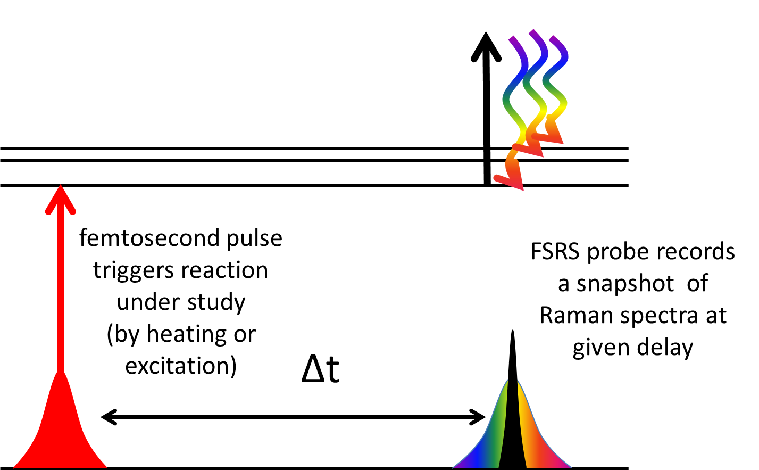

Stimulated Raman probe:
Time resolution ~100fs
Spectral resolution ~1 cm⁻¹
Observed spectral window 30 - 4000 cm⁻¹
Raman pulse wavelength 760-840 nm

Triggering pulse pump:
Time resolutions ~ 30fs
Spectrum ~ 50 nm
Available wavelengths 266 nm, 400 nm, 800 nm (being extended to 230-2600 nm)
Pump-probe delay 0 – 6 ns, 10 fs resolution

- Optical transient absorption
Optical transient absorption is an experiment where changes in the sample absorbance are recorded with high time resolutions. It is very robust technique for characterization of excited and transient states of molecules, atoms and materials.

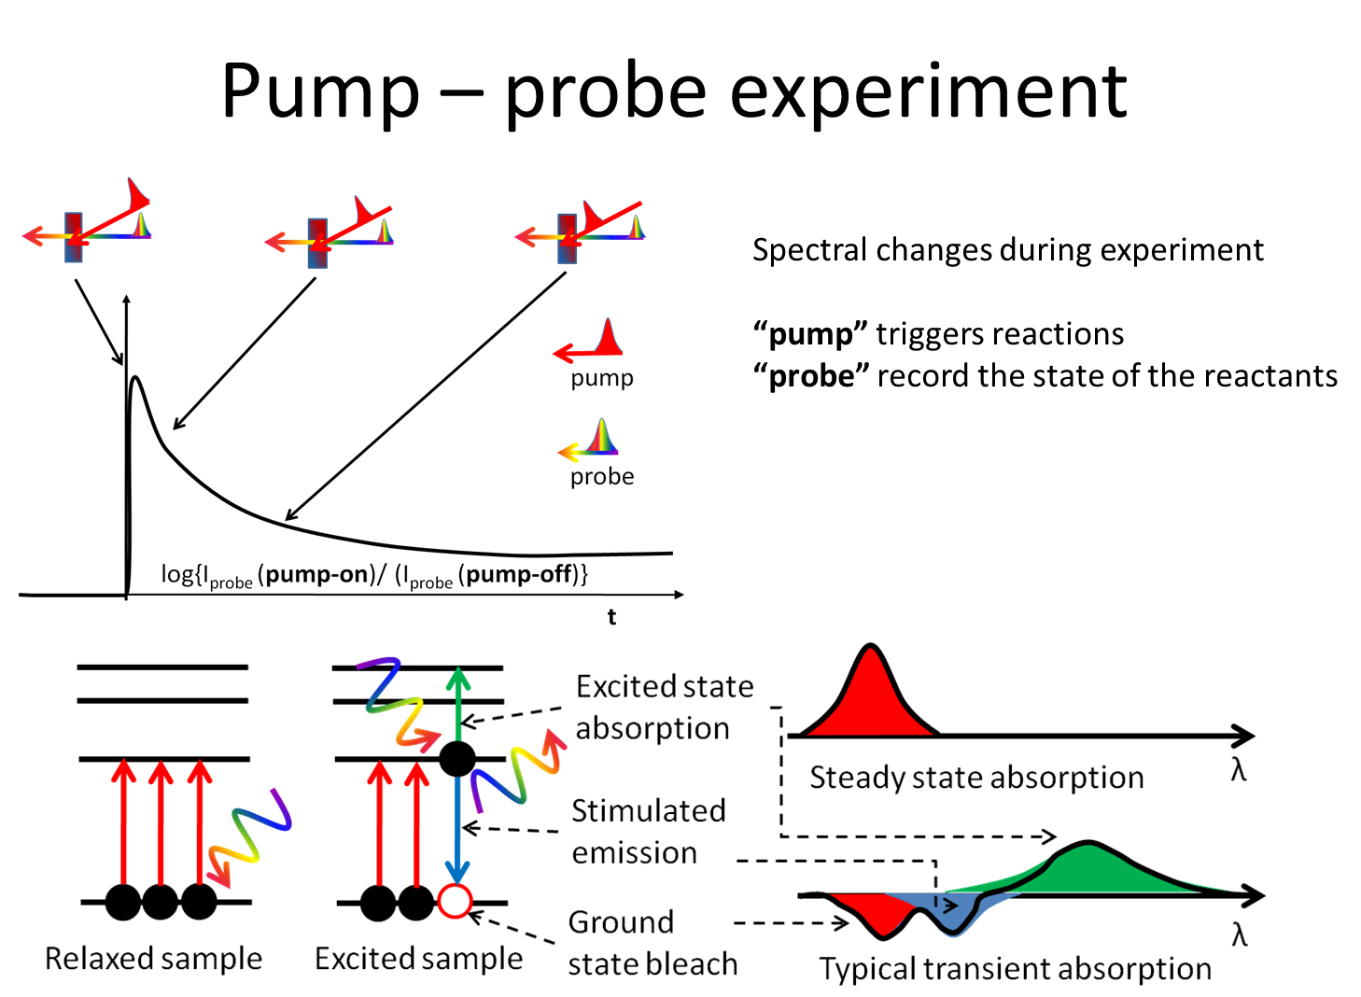

Probe pulse:
Time resolution ~20fs
Spectral resolution ~1 nm
Observed spectral window 266 – 2500 nm

Triggering pulse pump:
Time resolutions ~ 30fs
Spectrum ~ 50 nm
Available wavelengths 266 nm, 400 nm, 800 nm (being extended to 230-2600 nm)
Pump-probe delay 0 – 6 ns, 10 fs resolution

- IR spectroscopy (1 and 2D)
Femtosecond mid IR spectroscopy is a tool for study of bond structure of molecular and solid state systems. Vibrations spectra are recorded with fs time resolutions. That allows following conformational changes such as isomerization, bond braking, bond formation, solvent dynamics etc.…
2D IR spectroscopy is technique for observing cross-talk between individual bonds. Such experiment is analogue of 2D NMR experiments. In the same way it produces data that are more rich in structure-related information, but with possibility to record them with femtosecond time resolution.

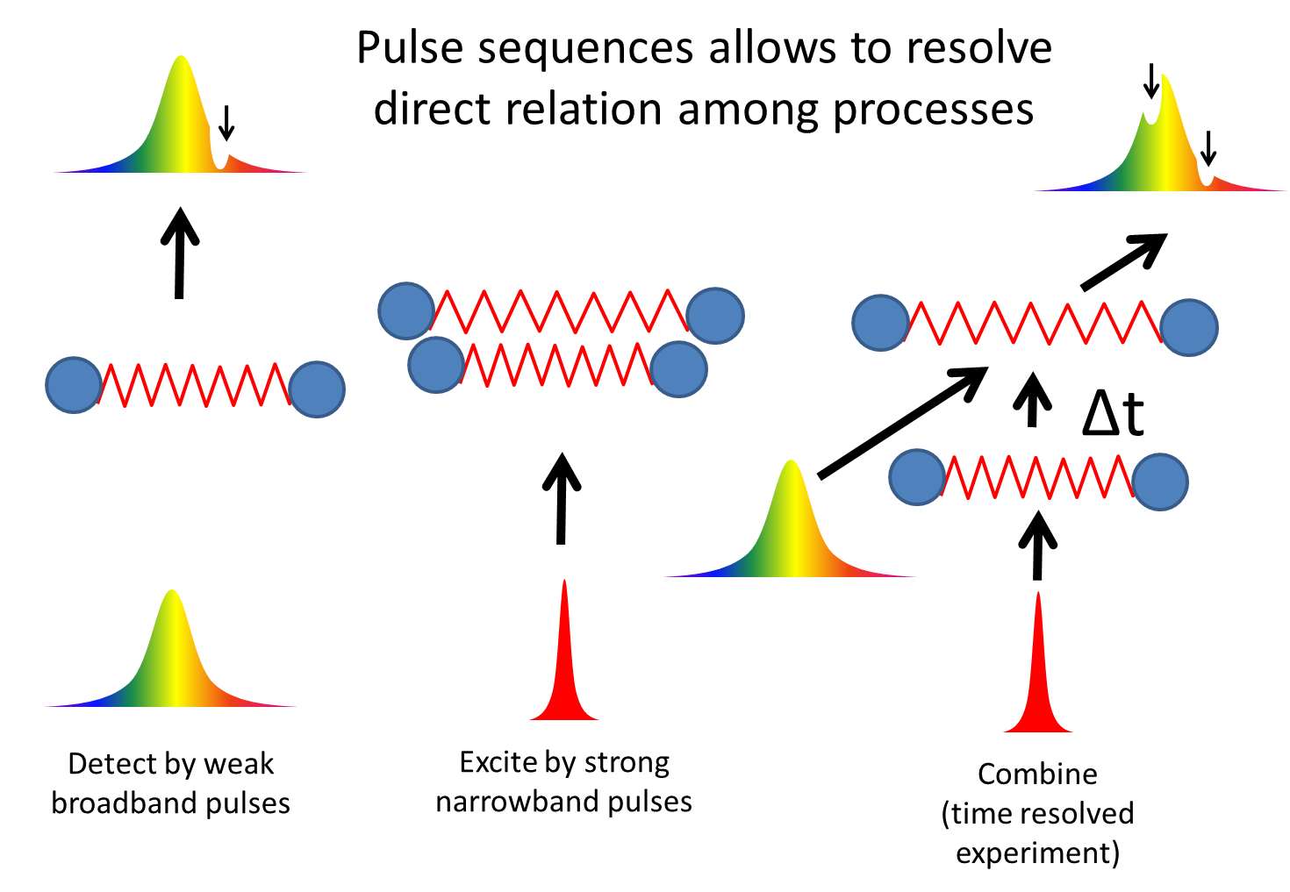

Probe pulse:
Time resolution ~100fs
Spectral resolution ~0.1 cm⁻¹
Observed spectral window 2600 nm – 10000 nm

Triggering pulse pump:
Time resolutions ~ 30fs
Spectrum ~ 50 nm
Available wavelengths 266 nm, 400 nm, 800 nm (being extended to 230-2600 nm)
Pump-probe delay 0 – 6 ns, 10 fs resolution

- Pulse shaping and coherent control
Pulse shaping is a technique that allows to model spectral and temporal profile of the pulse. This has versatile applications the fields such as multidimensional spectroscopy, coherent control, and spatial and temporal signal encoding atc.

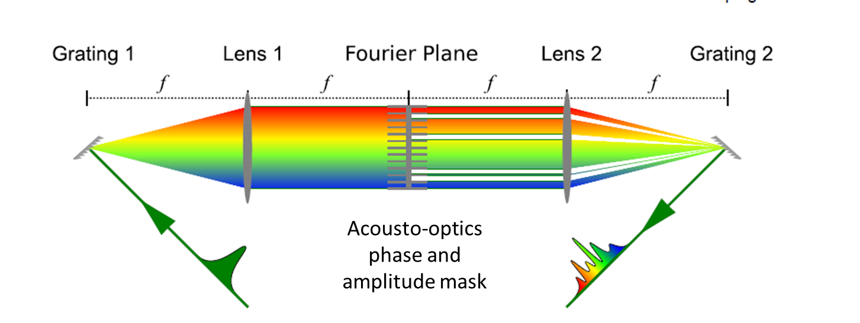

Shaping pulse properties:
Time resolution ~5fs
Spectral resolution Tunable down to ~0.1 cm⁻¹
Available spectra window 266 nm – 2600 nm
Maximal “pulse shaping generated delay” 10ps

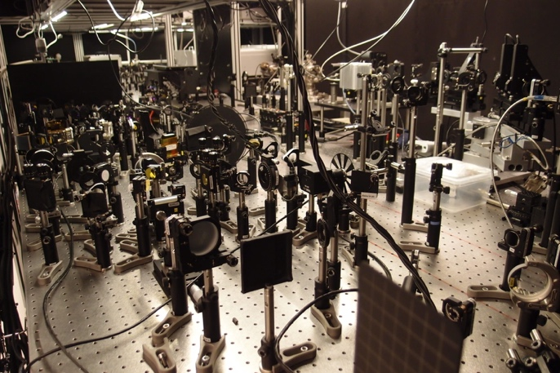 | 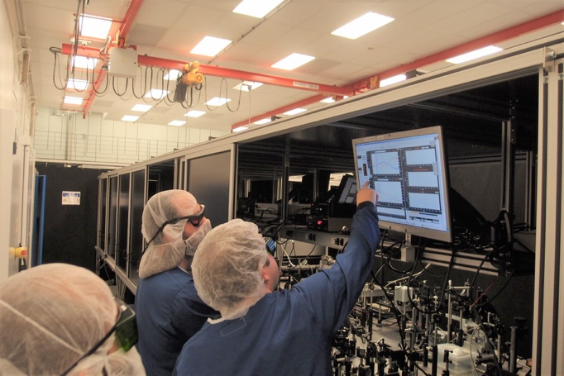
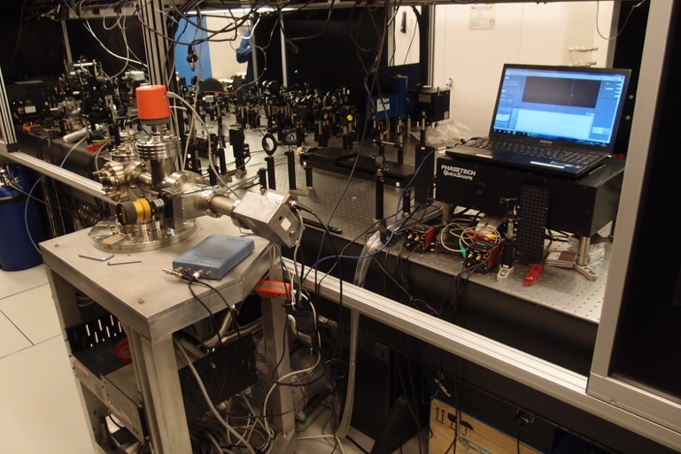 | 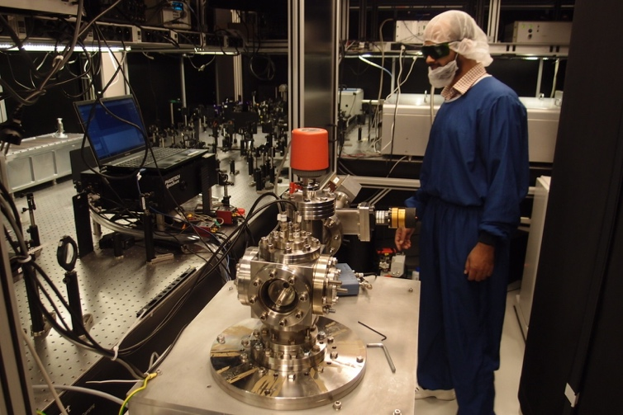
Fig: Top: Set up for fs Stimulated Raman Scattering in operation in the E1 experimental hall. Bottom: Set up for pulse shaping in operation together with a time-of-flight mass spectrometer during a user experiment where the effect of shaped pulses on catalytic reactions were investigated.

L1 Allegra - brief description and expected parameter development
L1 is based on amplification of picosecond pulses in broadband OPCPA and compressed to <20 femtosecond using chirped mirrors. The pump lasers are based on Yb:YAG thin disk technology. For pump probe experiments part of the L1 beam can be split off the main beam and converted according to the needs of the user. The expected L1 parameters development and availability of user experiments are summarized in the table below.

Period | Compressed laser beam parameters | Laser time for experiments^{*)}
Period 0 – pre commissioning and commissioning  March 2019 (>30 mJ beam) | <30 mJ / <30 fs / 1kHz | 2 weeks of E1 BT commissioning work at 100 % laser availability in E1
Period 1 – commissioning and user program  April 2019 | >30 mJ / <30 fs / 1 kHz | 4 weeks of E1 commissioning work and user experiments at 100 % laser availability in E1
Period 2 – commissioning >50 mJ
May 2019
Period 3 – user program (interleaved with further commissioning in E1)  June 2019 – Nov 2019 | >50 mJ / <20 fs / 1 kHz | 18 weeks of user experiments at 70 % laser availability in E1.  8 weeks of regular maintenance
Period 4 – commissioning >100 mJ
Dec 2019 –Jan 2020
Period 5 – user program  Feb 2020 – Jan 2021^{#)} | >100 mJ / <20 fs / 1 kHz | 35 weeks of user experiments at 70 % laser availability in E1  10 weeks regular maintenance  5 weeks of large maintenance and upgrade
100% laser availability means 8 h per day, 5 days per week.

Support lasers

Coherent Astrella, brief description and expected parameters
For initial methods development and for future support for the L1 laser a Coherent Astrella laser is available

 | Energy - compressed | Pulse duration  At target | Repetition rate | Note
Coherent Legend | 6 mJ | <40 fs | 1 kHz
Table: Coherent Astrella parameters.

Femtolaser Femtopower, brief description and expected parameters
For initial methods development and optical spectroscopy applications a Femtopower laser from Femtolaser is available.

 | Energy - compressed | Pulse duration  At target | Repetition rate | Note
Femtopower | 4.5 mJ | <30 fs | 1 kHz
Table: Femtolaser Femtopower parameters.

Higher Harmonics Generation (HHG), brief description and expected parameters of the HHG source

HHG Beamline
High-order harmonic generation in noble gas is employed to produce a stable source of coherent femtosecond pulses in the XUV spectral range. The beamline allows for modification of the driving laser focusing for given generation scheme (noble gas) maximizing the conversion efficiency. Complete set of diagnostics is available for full characterization of the beam provided to the end-station. Expected pulse energy for various laser drivers is listed in Tab. 1.

Laser driver  Wavelength | 30 mJ (L1) | 12 mJ  (Legend Elite) | 6 mJ (Astrella)
50 - 120 nm | 500 | 100 | 50
30 - 50 nm | 50 | 10 | 5
10 - 30 nm | 5 | 1 | 0.5
Tab. 1 Expected XUV energy per pulse (nJ) generated using various kHz laser drivers in E1

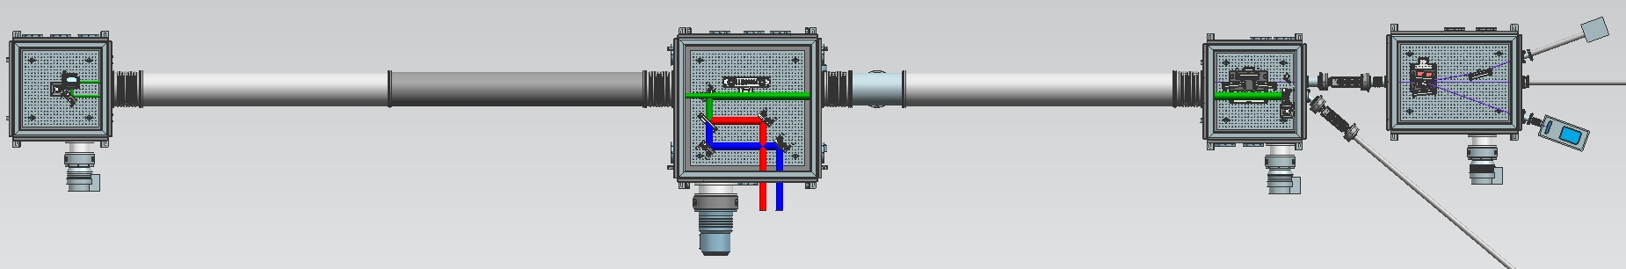

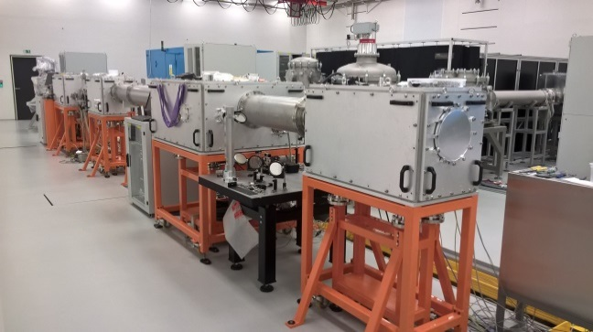
Fig: Model and picture showing the HHG source.

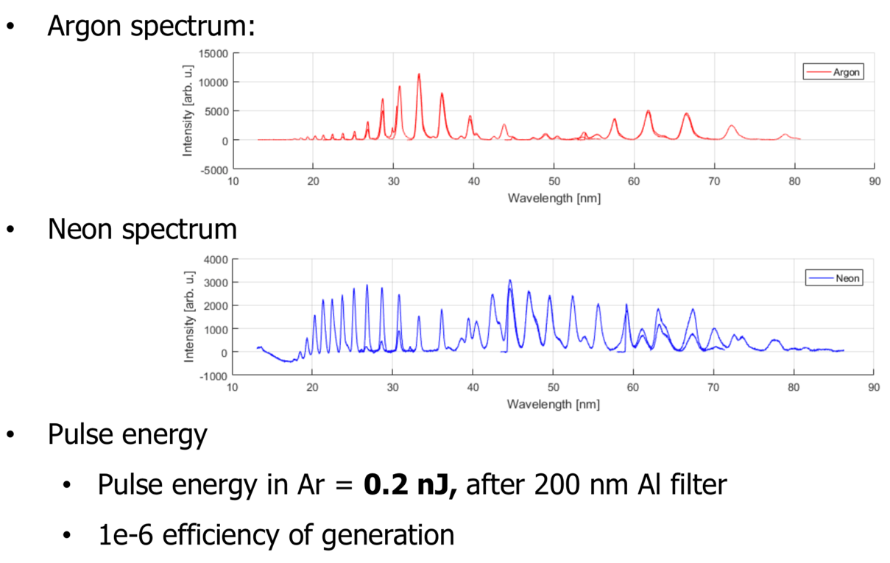

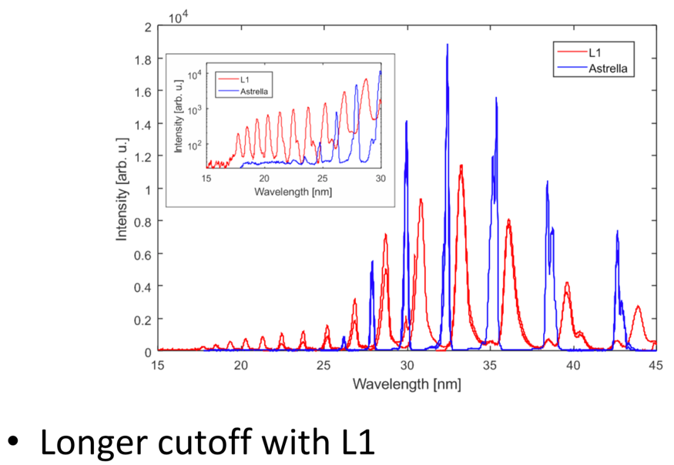

Rules for user-supplied instrumentation and equipment

Plans for bringing user-supplied instrumentation and equipment must be immediately communicated to the instrument scientist of the instrument where the equipment is to be used. Ideally already in the beamtime application.

Complete technical documentation of the user-supplied instrumentation or equipment must be provided to the instrument scientist of the instrument where the equipment is to be used well in advance of the delivery of the instrument the ELI Beamlines.

Users who wish to bring their own instruments or equipment must be ready respond swiftly to requests for technical or safety related information by ELI Beamlines scientific, technical or safety staff.

User provided instruments and equipment will only be allowed to be used in the E1 experimental hall and associated experimental areas after passing safety and technical approval.

